Part I:

•The inheritance is relationship between 2 classes. The advantages are save time, and make high quality classes.

•The relationship between base class and derived class is base class access the public and protected members from derived classes, and private members only used in the same class.

•MustInherit modifier only use in base class and Inherits, and NotInheritable use in derived class.

•NotOverridable, Overrides and MustOverride use in base class and we only can use overrides in derived class.

•In Base class’s constructor should be declare as public so we can use it in derived class.

•Polymorphism is relationship between more than 2 classes.

•Abstract class is method only declares in base class and it works as inherit but it will take some method with it to derived class. Must is keyword for abstract class. The purpose is providing an appropriate base class from other classes can inherit and implement.

•The differences between abstract class and concrete class is concrete is declaring an abstract class, and abstract is declaring methods in the base class.

•Abstract class can’t be used to instantiate an instance directly

Part II:

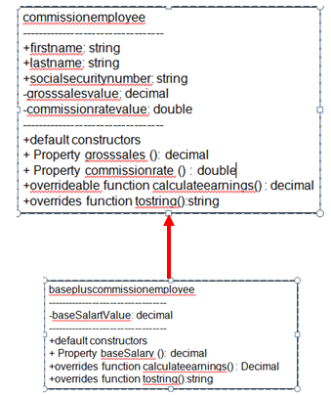commissionemployee Class

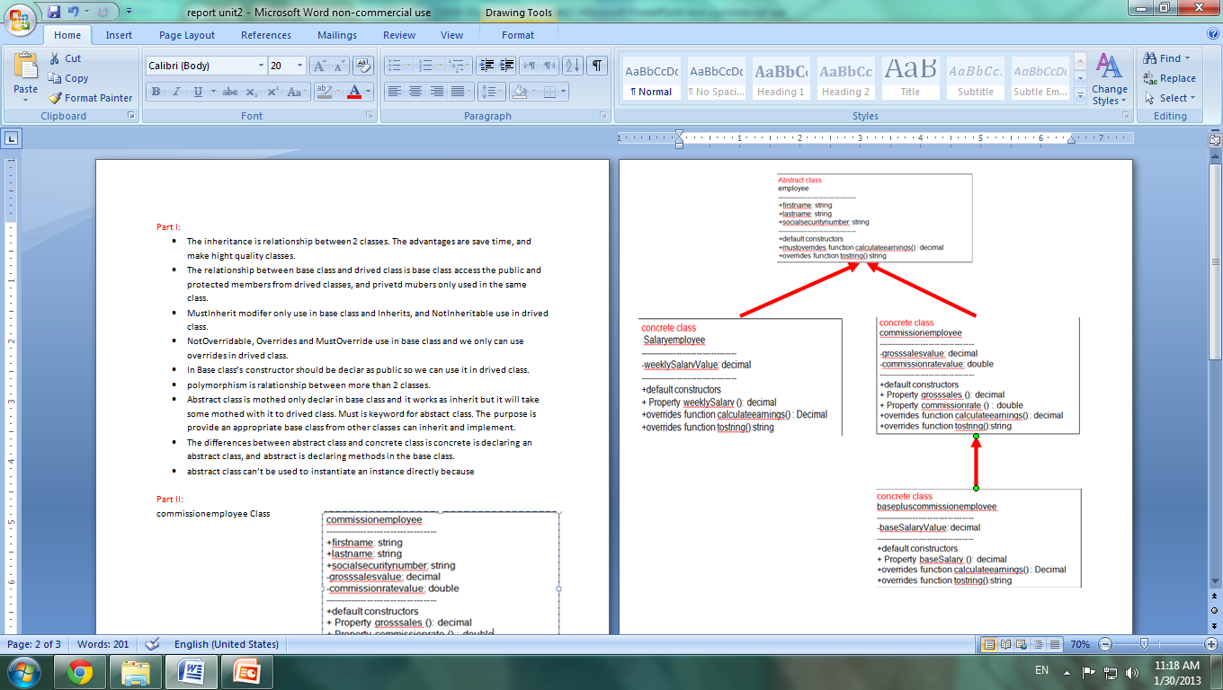

Employee Class

Part III:



